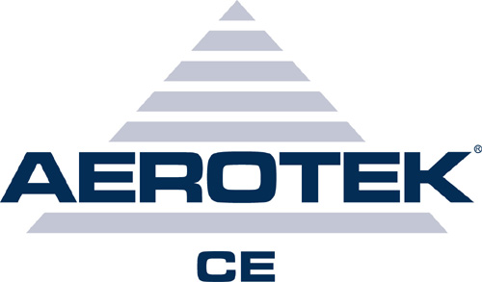

JAMES W. CATONE

EDUCATION UNIVERSITY OF ARIZONA, Tucson, AZ
Bachelor of Science in Mechanical Engineering, December 1991, 3.4 GPA

EXPERIENCE Astronomical Consultants and Equipment, Matt Salviano, 891-7977 Tucson, AZ
9/06 – 6/08 Mechanical Engineer
• Design and develop research grade one meter optical telescopes
• Produce fabrication drawings at the part,
subassembly and overall assembly levels
for each telescope
• Develop 3D model of telescopes and individual instruments using SolidWorks 2008
3D software
• Develop drawing formats and drawing numbering scheme for all fabrication drawings
• Produce inclusive parts lists for individual instruments and entire telescopes
• Assist in maintenance of existing telescopes on both Mt. Lemon and Kitt Peak observatories

10/04 – 6/06 U of A LUNAR AND PLANETARY LABORATORY, Roger Tanner, 621-1218 Tucson, AZ
Staff Mechanical Engineer, Phoenix Mars Lander 2007 Project, EID# 062001885
• Designed and produced fabrication drawings for the RAC and some of the SSI components
• Developed 3D model of the SSI and RAC using Mechanical Desktop
• Developed extensive parts lists for Surface Stereo Imager (SSI) and the Robotic Arm Camera (RAC)
• Participated in weekly status meetings to review design and development progress
• Analyzed and corrected galling problem in drive mechanisms
• Installed mission critical flight cameras on Mars Lander in clean room at JPL

1/04 – 9/04 EOS TECHNOLOGIES, INC., Gordon Pentland, 624-6399 Tucson, AZ
Mechanical Engineer, Opto-Mechanical Group
• All activities performed at this company complied with ISO 9001 protocols
• Designed and developed various mechanical components on the Lick 2.4 meter telescope
• Produced fabrication drawings for both mechanical and optical components
• Developed 3D model of the Lick 2.4 meter telescope using SolidWorks
• Successfully completed The Project Success Method Training Course offered by Project Management Institute
• Helped produce proposals for new projects

2/96 – 12/03 GEMINI 8M TELESCOPES PROJECT, Mike Sheehan, 974-2535 Tucson, AZ
Mechanical Engineer, Telescope Structure, Building and Enclosure Group
• Designed and developed the secondary support frame and top end vanes
• Coordinated purchasing and tracking of materials for construction of the Chile site
• Designed and supervised fabrication and installation of various telescope components
• Participated in several design reviews with the National Science Foundation and Gemini Oversight Committee
• Helped coordinate and troubleshoot the assembly of the telescope structures at both Hawaii and Chile sites
• Mechanical design and development of Gemini’s Multi-Conjugate Adaptive Optics, a precision real-time automated system used to compensate for atmospheric interference
• Designed various components (precision mounting brackets, etc.) using 3D modeling
• Developed 3D model of the telescope using AutoCAD and Inventor

5/95 – 2/96 MMTO, STEWARD OBSERVATORY, U of A, Shawn Callahan, 621-7649 Tucson, AZ
Engineering Assistant, Multiple Mirror Telescope Observatory
• Designed, drafted, and was production contact for various components of project
• Coordinated production of actuator assemblies
• Testing of critical support structure components to verify design compliance
SKILLS EQUIPMENT OPERATED:
• Standard office equipment, including fax machine and copier
• Industrial 10- and 20-ton punch presses
• Table and band saws, mill, wood and metal lathes, drill press, grinder, polisher
• Drills, sanders, jig and rotary saws, various hand tools
• Forklift

COMPUTER:
• IBM PC, Macintosh, VAX, Sun Workstation
• Programming in Assembly, FORTRAN and BASIC
• SolidWorks 2008, AutoCAD 3D, Mechanical Desktop, MathCAD
• Word processing, spreadsheets, presentation, database, hard drive recovery, anti-virus, etc.

